Thomas Jubb

MMA League Table
Computer Science NEA

Contents
User Interface 2
Decomposition 3
Inputs, outputs and processes. 4
User Interface 5
Data structure 6
Methods of Access 7
Database design - ERD 8
Data Dictionary. 9
Validation 10
Algorithms 11

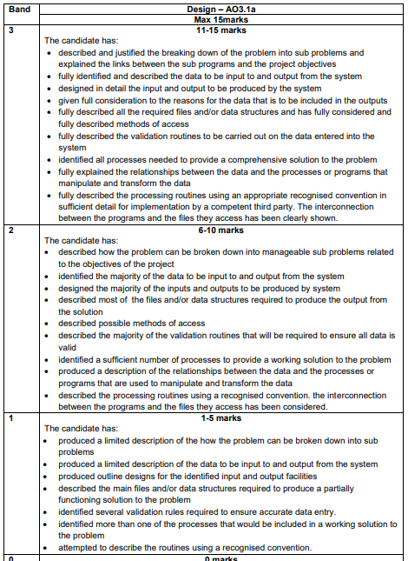
This is for your reference only and needs to be deleted when it is handed in as a final copy.

Please also delete any of my comments from the sections below, on final hand in

Decomposition
Your system needs to be broken into a series of sub-problems; each one should generate a different method. You need to justify each one, linking each to the objectives you agreed on at the end of the investigation, even if it feels obvious. These will then be used in each section of the design, so you will continue to refer to them.

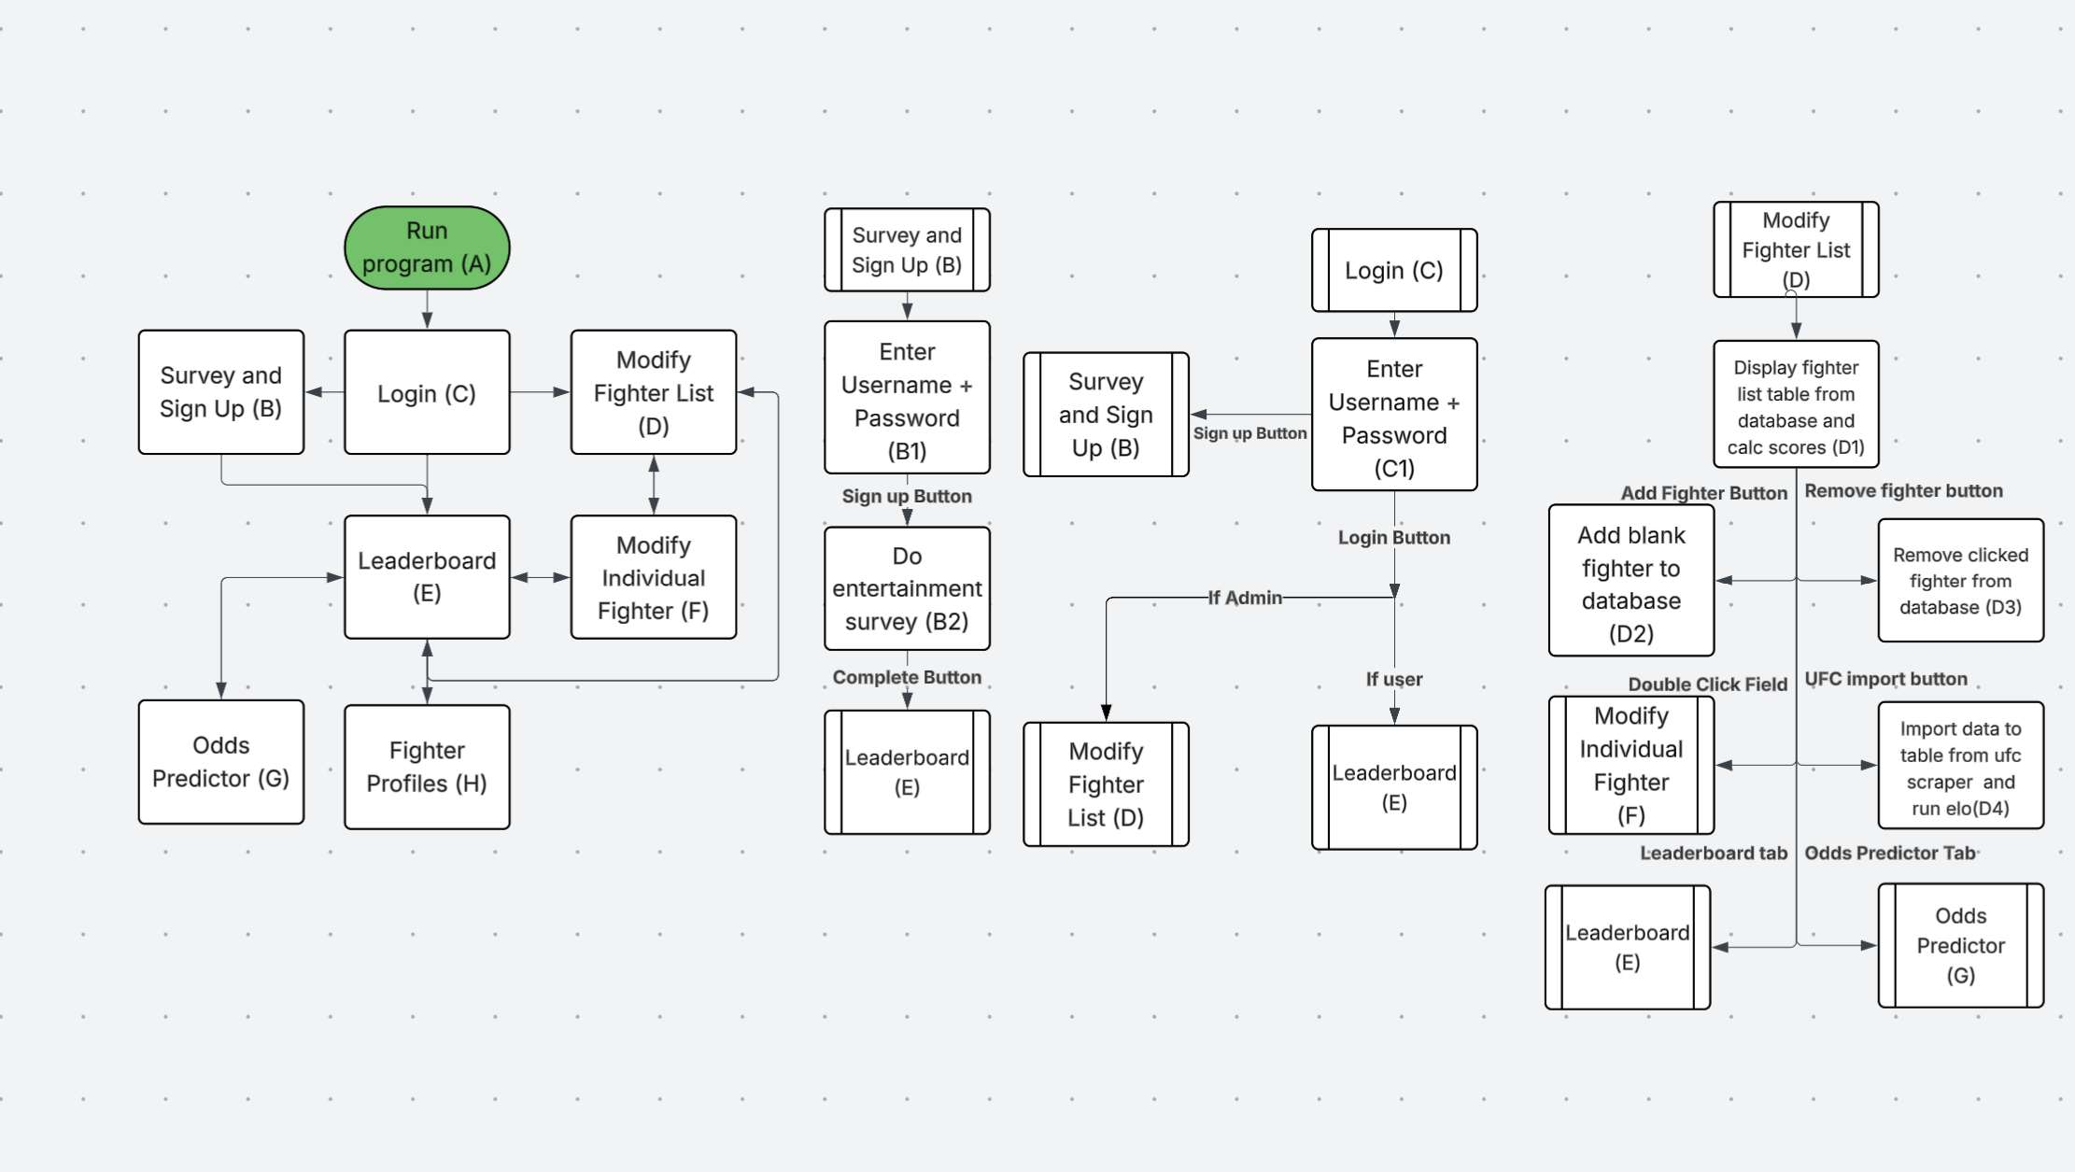
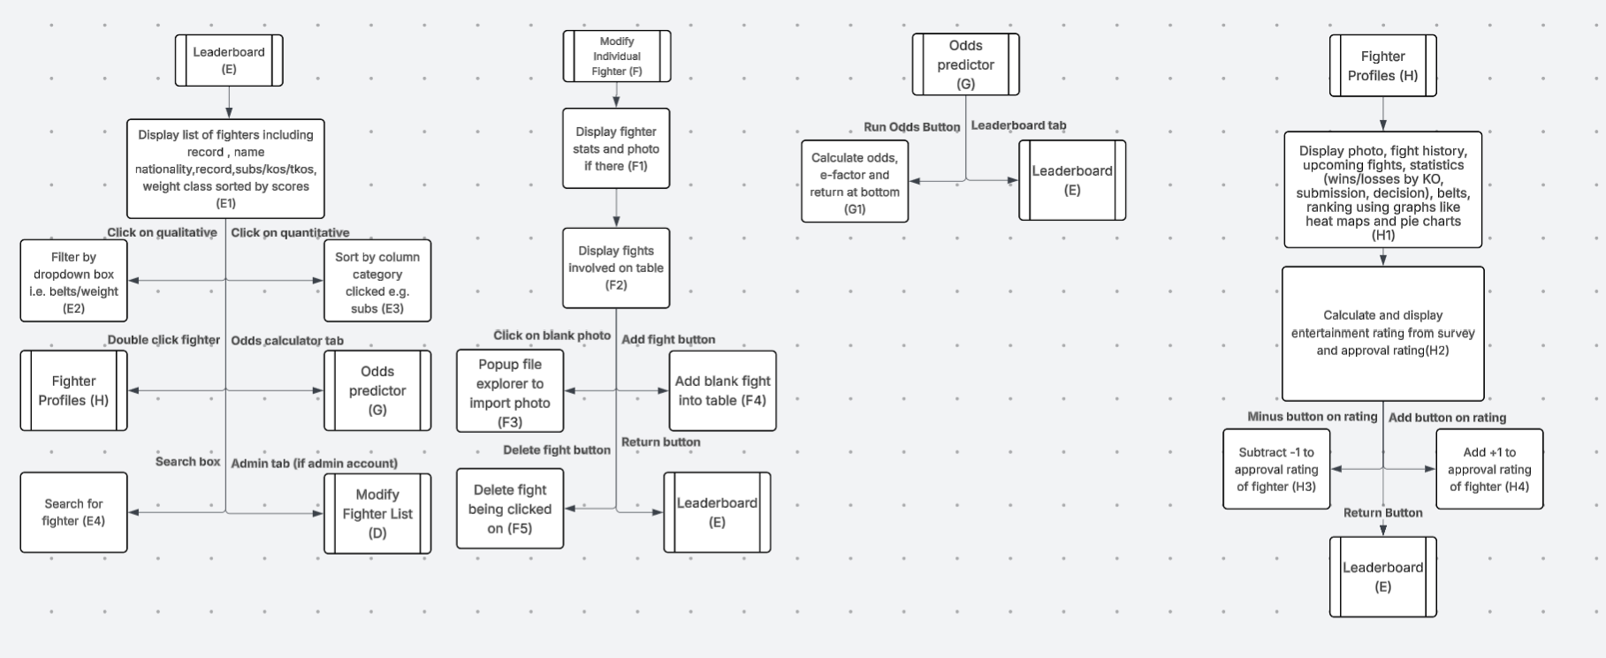
The letters and numbers signify a key. For example, (F5) is a part of Modify Individual Fighter (F), where it pops up the file explorer to input a photo

Inputs, outputs and processes.

For each of your sub problems you need to identify the inputs, outputs and processes.
Sub Problem Ref | Input | Process | Output
Page Redirects (General) | User/Admin does something which causes the page to redirect | Page variable is set to the current page; all the other pages not being used are hidden. | User/Admin is redirected to another page
Enter Username and password on signup (B1) *not to be confused with C1 | User enters their username and password into the box | Check if the username and password are valid, and then do an SQL query to add the user to the table as a regular user. Set the isAdmin variable to False, the session userID to the user’s new ID | If everything is valid, redirect to the user survey (B2). If the username or password isn’t valid, then show an error message.
Do the Entertainment Survey (B2) | User answers a questionnaire of ratings 1-10 about their opinion of submissions, knockouts, decisions, how valuable being unbeaten is to them and how valuable a streak is to them. When done, click the complete button. | Run an SQL query to add the answers to the questions to a table in reference to the user’s ID, which is figured out by the session userID. | Redirect to the Leaderboard (E)
Enter Username and password on login (C1) *not to be confused with B1 | User/Admin enters their username and password into the box or clicks the sign-up button. | Run an SQL query to figure out if the user exists and is an admin or not. If so, set isAdmin to True and vice versa. Set the session userID to the user ID found from the search. | If there is no match, show an error.  If the user is an admin, redirect to Modify Fighter List (D).  If the user is a regular user, redirect to Leaderboard (E)  If the user clicks the sign-up button, then redirect to Survey and Sign Up (B)
Display the  fighter list table from the database and calculate scores (D1) | On redirect to Modify Fighter List (D) | Do an SQL query to set all fighters to a default ELO of 1500 and then get all the fights in the database in chronological order. Go fight by fight and compute the way ELO scores are affected for each fighter involved from each fight using the Glicko-2 Algorithm. Turn each fighter’s name into lowercase and then a list of ASCII numbers, add together the numbers and put this value in a table with ID for searching. Do an SQL query to get the fighter table. | Output the fighter table onto the table on the page
Add Blank Fighter to the database (D2) | Admin clicks the "Add fighter” button | Run an SQL query to insert a new blank fighter into the fighter’s database using generic values | Output the new fighter addition onto the table
Remove the fighter from the database (D3) | Admin clicks a fighter’s field and then clicks the “Remove Fighter” button. | Run an SQL query to remove the fighter that is being clicked from the database, and all the fights involving them | Output the new table without the deleted fighter
Import UFC data to a table from the scraper and run ELO (D4) | Admin clicks an “Import from UFC” button and then a further “Are you sure?” pop-up | UFC scraper returns all active fighters and all fights since 2020. All the fighter and fight data is put into the tables, normalised and then all the fighters who aren’t recorded fighting are redacted. The system will check which fighters had belts and assign them their values. It will be the same thing as (D1), where a default ELO is assigned, the fights are put into chronological order, and the system calculates how the fighters involved in each fight have their ELO changed. | The table is updated with UFC fighters.
Display list of fighters including record, name, nationality, record, subs/kos/tkos, weight class, sorted by scores (E1) | User Navigates to Leaderboard (E) | The system runs an SQL query to return the fighter list sorted by highest ELO first, where it shows their record, name, nationality, methods of victory, and weight class. | The table is displayed through the table UI on the Leaderboard
Filter by dropdown box, i.e. belts/weight (E2) | User selects a belt or weight class from the box | The system runs an SQL query to return the fighter list from E1, but with only the ones that held whatever belt they specified or whatever one from a specific weight class | The table updates to the new filtered one.
Sort by column category clicked, e.g. subs (E3) | User clicks/double clicks the top part of a column | The system runs an SQL query on the current list criteria and instead sorts it descending by the category the user clicked, e.g. submissions. If the category gets double-clicked, then it will be sorted in ascending order | The table updates to the new sorted one.
Search for fighter (E4) | User inputs a name and then clicks the search button | The system turns the term lowercase and into an array of ASCII numbers, which it sums. It then takes the ASCII total table of the other fighters and makes a 2d array which has the differences of every single fighter’s total. The system then sorts it by the smallest difference first. The SQL table then gets output in the order of the IDs
Display fighter stats and photo if there (F1) | On redirect to (F) | Do an SQL query and find the photo of the fighter, and find all the stats of the fighter | Display the photo on the photo slot in the individual fighter page, and put the stats in editable boxes
Display fights involved on the table (F2) | On redirect to (F) | Do an SQL query of all the fights that have the fighter whose page has been opened | Display the result of the query in the table
Popup file explorer to import photo (F3) | Admin double-clicks the photo slot and selects a photo | An SQL query inserts the image and the fighter ID it comes from into a table | Display the image in the image slot
Add blank fight into the table (F4) | Admin clicks the “Add fight” button | An SQL query inserts a blank fight with the fighter whose page is open, being one of the fighters | Display the new blank fight on the fighter profile table
Delete fight being clicked on (F5) | Admin clicks a fight and the “Delete fight” button | An SQL query deletes the fight being clicked on | Display the new table without the fight that got deleted
Calculate odds, e-factor and return at the bottom (G1) | User selects two fighters from two drop-down boxes and then presses a “run odds” button | An SQL query retrieves both fighters’ data, such as their ELO and the records of the opponents they have won against. It then determines how much data it has. If it has enough, it runs the odds using the Glicko-2 model, and if it doesn’t have enough, it uses the Bradley-Terry model. The system also checks the fighter’s methods of victory and win streak, and matches them up to figure out how entertaining the person will find the fight | The program returns the percentage odds and the predicted entertainment factor of the fight
Display photo, fight history, upcoming fights, statistics (wins/losses by KO, submission, decision), belts, ranking using graphs like heat maps and pie charts (H1) | On redirect to (H) | Run an SQL query to retrieve the photo, belts, and ranking. Create an array of 3 items: wins, losses, KOs, subs, and decisions. Tally them up using an SQL query of all the fights involving the fighter. Generate a pie chart between sub/ko/dec, and then generate a pie chart based on wins/losses | Displays the fighter profile and info in charts and text format, and also shows the belts the fighter has
Calculate and display the entertainment rating from the survey and approval rating(H2) | After (H1) | Run an SQL query to get the opinion survey up and scale each quality to how much a fighter does that, i.e. if you value subs and the fighter does subs, the score goes up from the original score. | Display the entertainment rating as an amount from 1 to 10
Subtract -1 from the approval rating of the fighter (H3) | When the user clicks a -1 button on the approval rating of a fighter | Run an SQL query to add one to the disapproval votes of the fighter on a table, and redisplay the new percentage | Display the approval rating from the fighter profile
Add +1 to the approval rating of the fighter (H4) | When the user clicks a +1 button on the approval rating of a fighter | Run an SQL query to add one to the approval votes of the fighter on a table, and redisplay the new percentage | Display the approval rating from the fighter profile

User Interface
Don’t be deceived by the title, you need to design every form you will be creating, including error messages. These need to be fully annotated, you will be showing these to your peers, they should have enough detail to be able to pick up your idea and program it. You should link these with the objectives in the design or your decomposition tasks.

Data structure
Describe why you will be storing the data in a SQL database, what features it has that suit your project etc.

Methods of Access
You need to identify the methods of access for each of your purposes. These can be:
- Direct – searching directly using a primary key, highly efficient as it will only produce a single result, ie a customer number
- Indirect – searching using a variable that can be duplicated in a file, ie a customer name.

Database design - ERD
Please make sure you indicate the relationships in a recognised convention, crows feet for Many side of the relationship or any symbol using UML software. You can do this using the following.
- Using Word Shapes as an image
- Using UML software to draw the diagram.
- Hand drawing the diagram and scanning in as an image.

Data Dictionary.

EVERY table you have identified in your ERD MUST have its own Data Dictionary!! Each one should have its own separate table.
Table Name
Field Name | Data Type | Description | Validation | Key

Validation

Probably the most important aspect of the project. This is looked at to judge the level of the project. You need to explain the different validation you will use. You should discuss each validation technique you will use from above and any try except statements or additional python validation you will include.

Algorithms

Each sub problem you have identified needs an algorithm. I don’t need to see any user interface algorithms, but I need to see everything else. Please make sure you use suitable pseudocode, it can’t look too ‘pythony’

